* **Rules for explosives supplier:**
* Pricing and Marking:
* The packing and marking of goods should be according to explosives rules, acts and PESO guidelines.
* Invoice should be quoted in reference to running contract number, date and subsequent amendments, if any, for any change in price, extension of delivery dates.
* No supply should include any order or orders against the running contract invoice.
* A self-attested copy of valid PESO license and valid DGMS certificate should attached with running contract of supply of explosives accessories.
* Following certificate should be attached, whichever is applicable:
* In case of consignee vans:
  + - Van number and date of dispatch must be mentioned to the consignee.
    - An acknowledgement memo and materials details acknowledged by consignee, or his representative of the same date as above must be attached.
    - Other claims must be as per purchase order and schedule to the same.
* In case of suppliers’ vans:
  + - Van number and date of dispatch must be mentioned to the consignee.
    - An acknowledgement memo of the same date as above and materials acknowledged must be attached.
    - Other claims must be as per purchase order and schedule to the same.
* Along with acknowledgement memo, voucher mentioned in the certificate must be attached with each invoice.
* The explosives should be transferred through PESO approved vans.
* Supply of extra quantity:
* If an RC holder, failed to supply the cartridge explosives or accessories, the balanced/unsupplied quantity may be cancelled/reduced from the RC holder after giving due notice to him. The cancelled quantity must be re-distributed among RRC holders and other suppliers, as the case may be, with in that subsidiary company.
* The extra quantity must be supplied on ex-stock basis and the opportunity must be given to RC holder, if they failed to meet the said quantity then to RRC holders. The extra quantity, distributed among the RC/RRC holder may be done preferably in equitable manner but suppliers are must to ensure that the supplies must not be delayed on this ground. The subsidiaries have the liberty to procure extra supply from any/all the RC/RRC holder.
* If the required amount exceeds 40% of the RC quantity and RC holder is not able/willing to supply, the subsidiary company may allocate the additional quantity to RRC holder.
* From the date of issue of first allocation the RRC holder shall commence the supply within 15 days.
* Liquidated Damages
* If the supplier failed to fulfill the terms and conditions or to deliver or dispatch the equipment/stores in the said period/date as per mention in supply order, the purchaser have the following rights:
* To recover from the successful bidder as agreed liquidated damages, a sum not less than 0.5% of the price of any equipment/stores which the successful tenderer has not been able to supply as aforesaid for each week or part of a week during which the delivery of such stores may be in arrears limited to 10% of the total contract value, or
* To purchase elsewhere after due notice to the successful tenderer on the account and at the risk of defaulting supplier, the equipment/stores not supplied or others of similar description without Cancelling the supply order in respect of the consignment not yet due for supply, or
* To cancel the supply order or a portion thereof, and if so desired to purchase the equipment/stores at the risk and cost of the defaulting supplier and also,
* To extend the period of delivery with or without penalty as may be considered fit and proper. The penalty, if imposed, shall not be more than the agreed liquated damages referred above
* To forfeit the security deposit fully or in part.
* Whenever under this contract any sum of money is recoverable from and payable by the supplier, the purchaser shall be entitled to recover such sum by appropriating in part or whole by deducting any sum or which at any time thereafter may become due to the successful tenderer in this or any other contract. If the sum is not sufficient to recover the full amount recoverable, the successful tenderer shall pay the purchaser the remaining balance on demand. The supplier shall not be entitled to any gain on such purchase.
* For the purpose of the calculation of the liquidated damages amount, the basic for destination price shall be considered. Taxes and duties shall not be considered for calculation of LD.
* Risk Purchase:
* In the event of failure of the supplier to deliver or dispatch the stores within the stipulated date/period of the supply order on in the event of breach of any of the terms and conditions mentioned in the supply order/contract, consignee or its subsidiaries have the right to purchase the stores from elsewhere after due notice to the defaulting supplier at risk and cost of the defaulting supplier. In the event of failure of the supplier as detailed above, the cost as per risk purchase exercise may be recovered from the earnest money deposit/ security deposit/ performance security of the supplier and/or bills submitted by the supplier against the same contract or any other contract pending in the same subsidiary Co. and/or in any other subsidiary companies.
* Risk purchase action may be initiated by subsidiary companies under any of the following conditions:
* When the supplier failed to deliver the materials even after extending the delivery period.
* When the supplier fails to respond to purchasers’ request for supply of the materials and fails to provide any reason which is considered to be genuine, for the delay in supply.
* When the supplier fails to respond to purchasers’ request for supply of the materials and fails to provide any genuine reason and bonafide reason for the delay in supply.
* When the supplier breaches any of the terms and conditions of the supply order/contract and as a result fails to execute the order satisfactorily.
* **Plants and operating technology:**

|  |  |  |  |  |
| --- | --- | --- | --- | --- |
| **S. No.** | **Plant** | **Technology provider** | **Process/technology** | **Client** |
| 1 | Ammonium nitrate melt (AN melt) | Thyssenkrupp | uhde® Vacuum Neutralisation | Gujarat Narmada Valley Fertilizers & Chemicals Limited |
| 2 | Technical Ammonium Nitrate (TAN) | Casale SA | AN2000/Dual Pipe reactor | Smartchem Technologies Ltd. (a subsidiary of Deepak Fertilizer), (**Planned)** |
| 3 | Ammonium nitrate (AN) | Thyssenkrupp | uhde® Vacuum Neutralization | Deepak fertilizers, Taloja plant |
| 4 | Ammonium nitrate melt (AN melt) | Stamicarbon | ODDA process | Rashtriya Chemicals and Fertilizers Limited |
| 5 | Ammonium nitrate melt (AN melt) | **WIP** | **WIP** | National Fertilizers Limited |
| 6 | NA | NA | NA | Chambal fertilizers and chemicals Ltd. |
| 8 | Weak Nitric Acid (WNA) | Thyssenkrupp | uhde® dual pressure nitric acid process | Gujarat Narmada Valley Fertilizers & Chemicals Limited |
| 9 | Weak Nitric Acid (WNA) | Weatherly Inc. (U.S.A.) (KBR’s Subsidiary) | Weatherly Dual Pressure Nitric Acid Technology | Deepak Fertilizers |
| 10 | Weak Nitric Acid (WNA) | Thyssenkrupp | uhde® dual pressure nitric acid process | Rashtriya Chemicals and Fertilizers Limited |
| 11 | Weak Nitric Acid (WNA) | **WIP** | **WIP** | National Fertilizers Limited |
| 12 | NA | NA | NA | Kutch Chemical |

* **Thyssenkrupp: The Uhde dual-pressure process**
* Ammonia is mixed with atmospheric air and converted to nitrogen oxides over a platinum/rhodium catalyst. The design of ammonia burner ensures the even distribution of reactants resulting in very high conversion efficiencies.
* Steam and hot tail gas is produced in order to recover the heat of reaction. Now, the hot tail gas and a part of steam is used in turbines that drive the plant compressors, and the rest of steam is exported.
* Now, the cooling of process gas below the condensation temperature leads to form the first nitric acid.
* The next step is absorption, took place in cooled absorption tower where nitrogen oxides are absorbed in water. The nitrogen oxides remaining in the tail gas are at a low concentration enhancing overall plant efficiency.
* After absorption, the remaining nitrogen oxides are treated in EnviNox tail gas treatment, to reduce the nitrogen oxides to very low level to meet the emission regulations.

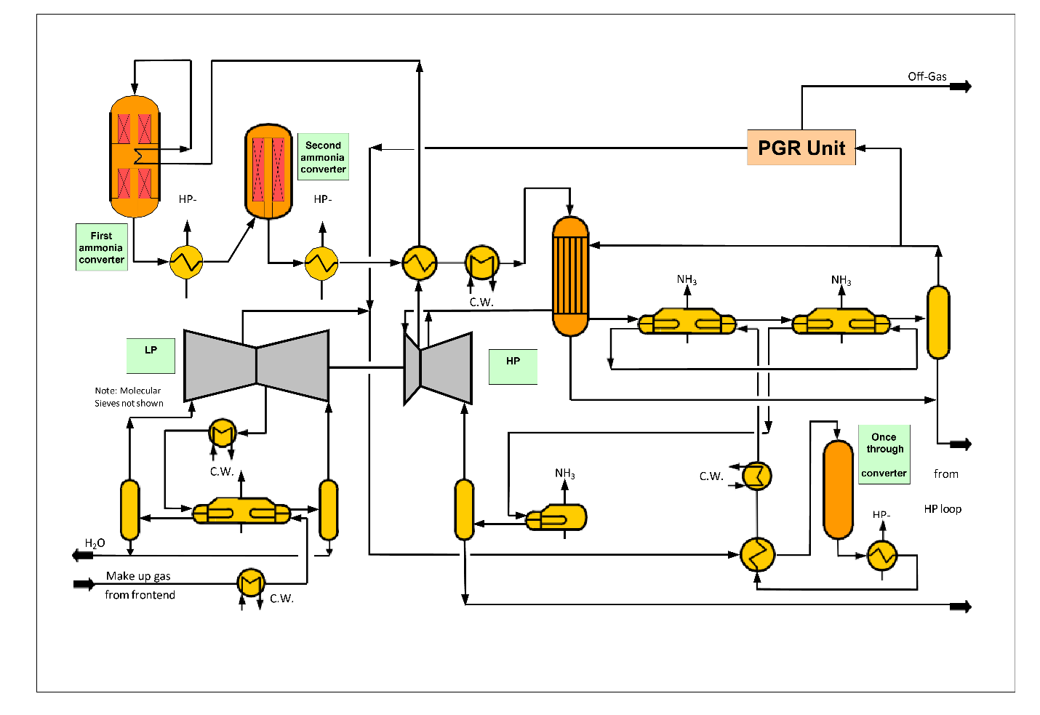

Source: Thyssenkrupp

The nitric acid process is known for its:

* High reliability and high on-stream time
* Easy maintenance
* Cost-effectiveness
* Energy efficiency
* Low emissions (BAT technology)
* **Weatherly Inc. (U.S) (KBR’s Subsidiary): Dual Pressure Nitric Acid Technology:**

Raw material used for producing nitric acid is atmospheric acid and ammonia. Atmospheric air used in production of nitric acid must be filtered, compressed, heated, and filtered again. Approximately 90% of horsepower is extracted, needed for compression from heated tail gas which is a highly efficient design feature. Liquid ammonia is prepared separately by filtration, vaporization, superheating and filtration again. After preparation of raw material, next stage is conversion and heat recovery. Next steps include the well mixing of air and ammonia and to evenly distribute over platinum catalyst. An exothermic reaction between ammonia and oxygen occurs which produce nitric oxide and water vapors. Now, the process gas is passed through the heat exchanger and major portion of reaction energy is recovered as heat and used to reheat the tail gas to provide power for the air compressor by driving a hot gas expander. The process gas is cooled and produced weak nitric acid. Before feeding into the absorption system nitric acid and remaining process gas are separated. Finally, nitric oxide, nitrogen dioxide, oxygen and water are combined in an absorber column, forming nitric acid of the desired strength.

Source: KBR

* **Thyssenkrupp: Vacuum Neutralization and evaporation:**

Ammonium nitrate is produced from gaseous ammonia and aqueous nitric acid in an exothermic reaction as follows:

NH3 + HNO3 → NH4NO3 – 3HR

The reaction took place in a slightly pressurized and neutralizer to minimizing the ammonia loss by boiling in the mixing and reaction section. Now, the solution is flashed into a vacuum through a restriction orifice adjacent to the vapor separator and utilizing the reaction heat for water evaporation. To achieve 95 wt% solution concentration, feed of 60 wt% nitric acid is required but the ammonium nitrate concentration is limited to 92 wt% due to control and safety reasons.

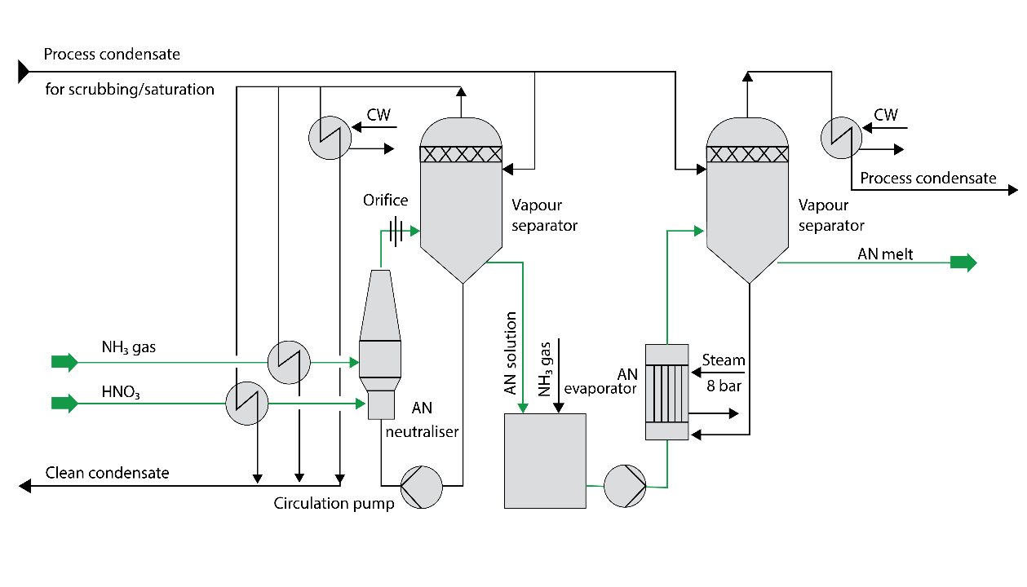 Source: Thyssenkrupp

* **Pressure neutralization:**

To utilize the heat of reaction more efficiently, the process vapor system operates above atmospheric pressure. Two major pressure neutralization alternatives for heat recovery are:

1. The heat stored in the ammonium nitrate solution, leaves the neutralizer used directly for the final concentration stage. There is no need to import additional steam even if 97 wt% concentration is required.

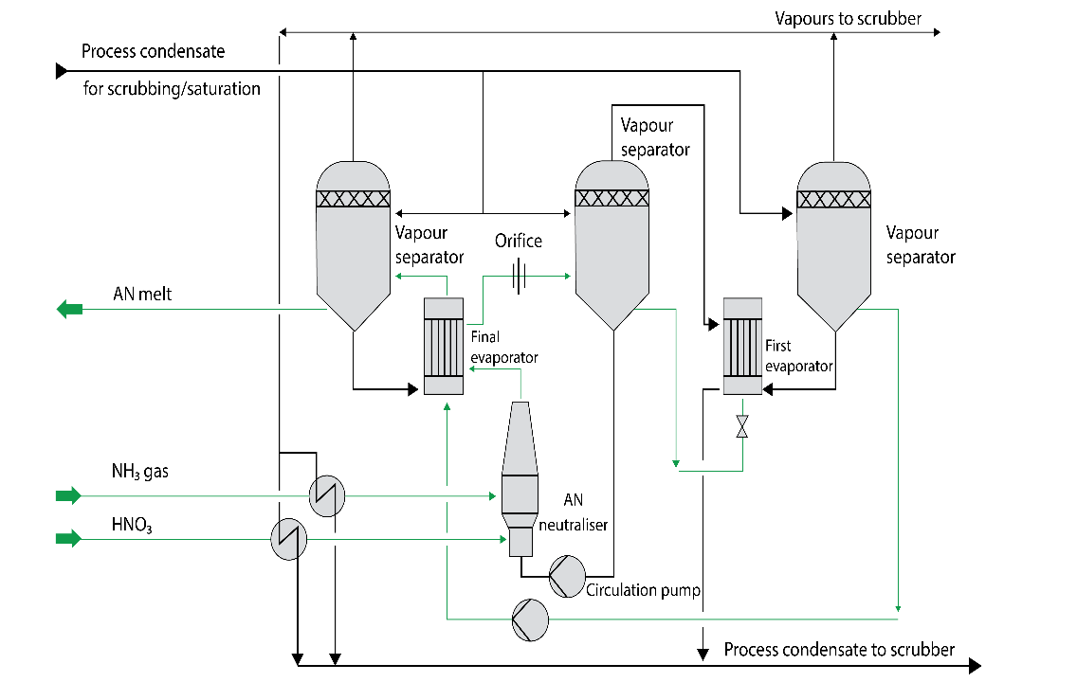

Source: Thyssenkrupp

1. For final concentration of ammonium nitrate solution, heating steam is imported while part of the heat of reaction is utilized to generate low pressure steam at approximately 5 bar abs.

Source: Thyssenkrupp

In both the above case, flash steam produced from the vapor separator at 2 – 4 bar abs are used for intermediate concentration of the weak ammonium nitrate solution and the remaining process vapors are used for feedstock preheating, surplus vapors are condensed. Depending on how the vapors condensate is to be used, some or all the vapors need to be scrubbed before condensation in a separate vapor scrubber.

* **Stamicarbon: ODDA Process:**

Liquid Ammonia received from ammonia plant is vaporized in Ammonia Vaporizer and auxiliary ammonia vaporizer. Ammonia vaporizer is shell and tube heat exchanger, in which cooling water is used in tube side for vaporization of ammonia in shell side. Vapor ammonia obtained from

ammonia vaporizer is superheated to 45-50 0C temperature in ammonia super heater using 2.5kg/cm2 steam. Vapor Ammonia and Nitric Acid (60% concentration) is fed to reactor in

the desired ratio. AN Reactor is vertical back mixing type of reactor. Ammonia and nitric acid react to produce 65% concentrated ammonia nitrate as follows:

NH3 (g) + HNO3 (lq) = NH4NO3 (lq) ................∆H = - 26.94 kcal/mole

Reaction is exothermic in nature. Heat released during reaction is taken away by the cooling water. There are three cooling zones in the reactor which consist of network of cooling water tubes. Temperature of reactor is maintained around 60-65 oC and pH is maintained between 7.0 - 7.2. Dilute Ammonium nitrate (65%) from reactor is collected in holding tank, which is in circulation with reactor. Level in the reactor is maintained using level control valves. Dil. AN from holding tank is pumped to AN buffer tank (Dil. AN storage tank). Reactor vent is connected to scrubber for scrubbing of gases leaving the reactor.

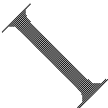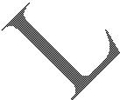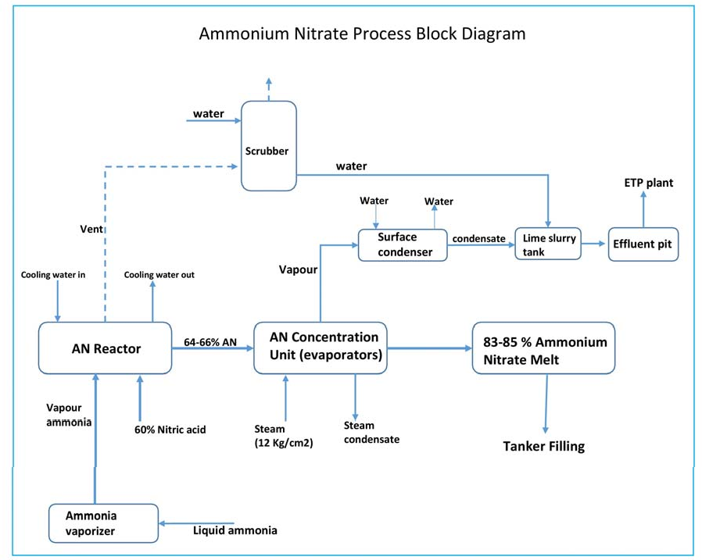

Source: RCF EIA report

Casale SA: AN2000TM:

The AN2000™ is the process to produce ammonium nitrate solution (ANS), based on Casale's pipe reactor technology.

Preheated ammonia and nitric acid feeds are mixed in a specially designed tubular reactor at 7 - 8 bar pressure. Instant formation of ammonium nitrate occurs by releasing a significant amount of heat. Finally, the hot ammonium nitrate solution enters a vessel/separator where the steam is released vigorously from the solution and the liquid ammonium nitrate solution is collected from the bottom of vessel and sent to storage.

While collecting steam from the tubular reactor, it carries some mist of ammonium nitrate solution and traces of ammonia vapors which is eliminated by multiple process:

* Scrubbing: In the Venturi-type scrubber, the process steam is de-superheated and a acidic scrubbing liquor is fed through a sprayer and a reaction occurs with the ammonia traces present in the process steam. A Cyclonic Column is present at the downstream of venturi-type scrubber, which is responsible for the recirculation of the liquor.

To recover the ammonium nitrate aerosol, the de-superheated process steam passes through a set of high efficiency demisters before the steam leaves cyclonic column. The excess of scrubbing liquor generated from the cyclonic column is directly discharged to the ANS solution tank or the pipe reactor.

The steam leaving from the scrubbing system is used to preheat the nitric acid feed, to vaporize and superheat the ammonia feed and to clean the concentrated process condensates.

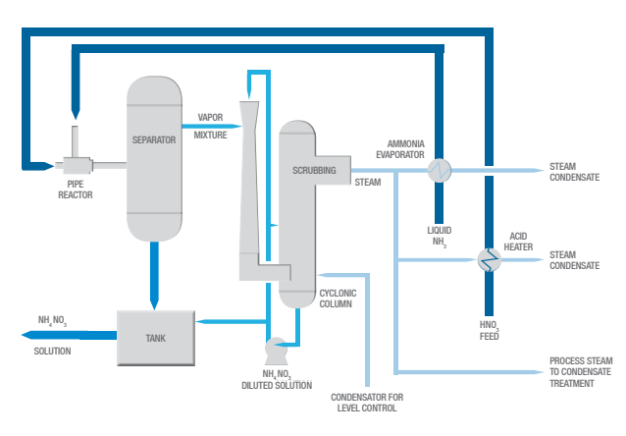Source: Casale

* **Key Features:**

|  |  |
| --- | --- |
| Technology | Features |
| Thyssenkrupp AN | -          high reliability and high on-stream time |
| -          low maintenance by process design, low corrosion because of low temperatures |
| -          cost-effectiveness |
| -          excellent safety standards by process principle, design, and control |
| -          energy efficiency |
| -          very low liquid effluent contamination, virtually no gaseous effluents |
| Thyssenkrupp WNA | -          high reliability and high on-stream time |
| -          easy maintenance |
| -          cost-effectiveness |
| -          energy efficiency |
| -          low emissions (BAT technology) |
| INCRO- AN | -          A patented heat integration scheme allows getting 96% solution without imported steam, in spite of the low operating pressure |
| -          The loop mixing scheme allows operating the plant in a wide capacity rage (20-120%) |
| -          The low operating pressure / temperature greatly increases intrinsic process safety |
| -          Extremely low ammonia / nitrate emissions thanks to the low temperature and mixing arrangement |
| -          Low operating pressure allows using ammonia as free cooling agent |
| - Reaction systems are energy self-sufficient and incorporate high efficiency scrubbing systems, fully integrated with the reaction and concentration equipment. |
| -          Resulting solution has many uses |
| -          Raw material at 95-96% concentration to manufacture low density porous ammonium nitrate (explosive grade LDAN / PPAN) in a prilling tower |
| -          To be directly dispatched for fertilizers production or explosive emulsions, at the concentrated required by end-user (80-90% typically). |
| -          To feed an attached granulation plant (90-97%), for NPKs or CAN production. |
| -          To be concentrated till 99.5-99.8% for AN / CAN fertilizers grade prilling. |
| Casale SA- TAN | -          Higher safety, due to the reaction zone’s intrinsically low residence time |
| -          Low OPEX, since highly concentrated ANS is directly obtained without any concentrator |
| -          Low CAPEX, due to reduced equipment compared to traditional process |
| -          Easy and fast start-up and shutdown |
| -          Clean process condensate recovery with AN concentration less than 30 ppm |
| Plinke GMBH- WNA | KBR's PLINKE technologies can be used in different applications: |
| -          Concentration of diluted acid streams for processes, where high-concentration nitric acid is required |
| -          Recovery of spent nitric acid for reuse in the process or for resale |
| -          Removal of nitric acid from wastewater for yield and/or environmental reasons |
| Weatherly Inc.- WNA | Low capital cost – KBR’s Weatherly technology operates at a higher |
| pressure than competing processes, so equipment is smaller and less |
| expensive, reducing the overall plant investment |
| -          High ammonia conversion – emphasizing clean raw materials, thorough mixing, even distribution and stable temperature, the design delivers extremely high ammonia conversion. Also, the catalyst basket design significantly enhances conversion. On average, the system maintains efficiencies of 95% or higher |
| -          Low catalyst cost – the process combines the latest development in platinum recovery systems with KBR Weatherly’s high ammonia conversion resulting highly efficient platinum use |
| -          Low NOX emissions – KBR Weatherly’s proven extended absorption design delivers superior NOX emissions performance; even lower emissions are possible by coupling with catalytic NOX reduction systems |
| -          Reduced maintenance cost – the vertical equipment arrangement minimizes piping runs and expansion problems, reducing maintenance expense |
| -          Minimal site area requirements – KBR Weatherly’s plants are vertically oriented and utilize smaller equipment-site area demands are minimal |
| -          Energy recovery – KBR’s plant design obtains energy recoveries as high as 5.23 GJ per metric ton (4,500,000 BTU per short ton). Each plant is customized to minimize costs |

* **Leakage of ammonia from storage tank / plant:**
* In case of vapors leakage, water must be sprayed to mitigate the vapor loss which may leads to increase the quantity of effluent.
* Generally, effluents are not allowed to discharge into the storm water drain but if required in any case of emergency then the storm water drain must be equipped with bund/barrier so that it won’t allow the effluent to pass further and can be treated lately.
* Ammonia should be neutralized immediately on transferring of contaminated effluent to ETP, and a person should be there to monitor the ammonia level near the gates.
* If in case, contamination is more than the Threshold Limit Value (TLV) i.e 25 PPM, the chief emergency controller must inform police to initiate the off-site emergency.
* All the associated valves must be isolated and tanker unloading must be stopped if there any.
* All the pumps also to be stopped.
* **Process of mitigating effluent:**
* Ammoniacal Loop:

Source- NH3/AN/ANP/MeOH/IPA Plants

Pollutants – Ammoniacal and Nitrate Nitrogen

Ammoniacal nitrogen is removed by volatilization of the gaseous Ammonia into air with help of

Stripper.

NH3 + H2O---->ammonium ion + hydroxyl ion.

After removing ammoniacal nitrogen, effluent contains mainly nitrates

* Nitrate Loop:

Source- ANP/AN/WNA/CNA/Tank Farm.

Pollutant- Nitrate Nitrogen

Nitrates in the wastewater are removed by biological treatment. Nitrate reduction can be achieved by

Aerobic and Anaerobic process. In our ETP, we are using anaerobic process for nitrate reduction.

* De-nitrification: The process by which microorganisms reduce nitrate ions to nitrogen gas.

The process of Nitrate dissimilation occurs through a complex series of reaction catalyzed by enzymes.

General Reaction: -

Nitrates Nitrites Free N2

* **List of hazardous waste:**

|  |  |  |  |  |  |  |  |
| --- | --- | --- | --- | --- | --- | --- | --- |
| **Sr. No.** | **Name of waste** | **Source of generation** | **Category** | **As per EC** | **Proposed/Additional** | **After Expansion** | **Disposal Method** |
| 1 | Discarded containers, drums | Receipt, storage, and handling of raw/packing materials | Sch-I/33.1 | 500 nos. per year | 500 nos. per year | 1500 nos. per year | Collection in drums, storage and transportation to authorized recyclers /authorized TSDF |
| 2 | Used/Spent Oil | Process / rotary machines / transformers | Sch-I/5.1 | 107 MTPA | 20 MTPA | 127 MTPA | Collection in drums, storage, transportation and sales to authorized recyclers. |
| 3 | Spent Catalyst | Process | Sch-I/18.1 | 660 MTPA | 0.1 MTPA | 660.1 MTPA | Regeneration / Recycle through catalyst supplier |
| 4 | Nox abatement Spent Catalyst | Nitric Acid Plant | Sch-I/18.1 | 0 | 10 MT in 5 years | 10 MT in 5 years | Collection in drums, storage and transportation to authorized recyclers /authorized TSDF. |
| 5 | Chemical sludge from wastewater treatment | Wastewater treatment schemes | Sch-I/35.3 | 17000 MTPA | 900 MTPA | 17900 MTPA | Chemical Sludge from wastewater treatment scheme is being disposed to cement plants for co-processing / TSDF, Udaipur |
| 6 | Contaminated cotton waste or other cleaning materials | Maintenance and cleaning activities | Sch-I/33.2 | 12 MTPA | 5 MTPA | 17 MTPA | Collection, storage and transportation to Common incinerator |

* **Government standards for ammonium nitrate and weak nitric acid effluent:**

|  |  |  |  |  |  |
| --- | --- | --- | --- | --- | --- |
| **S. No.** | **Parameter** | **Standards** | | | |
|  |  | **Inland surface water** | **Public sewers** | **Land of irrigation** | **Marine coastal areas** |
| 1 | Ammonical | 50 | 50 | -- | 50 |
| Nitrogen (as N), mg/l Max. |
| 2 | Free ammonia (as NH3) mg/l, Max | 5 | -- | -- | 5 |

|  |  |  |  |
| --- | --- | --- | --- |
| **S. No.** | **Industry** | **Parameter** | **Standards** |
| 1 | Nitric Acid | Oxides of Nitrogen | 3 kg/tonne of weak acid (before concentration) produced |